## CSC 120 Lab 04

#### Lab instructions and guidelines

1. This lab is about becoming confident in your ability to write code to perform simple tasks.
2. The aim is to help you build fluency while writing code with just the right amount of examples.
3. Feel free to reach out to me directly about any other questions or concerns.
4. As always, you may refer to and read online code but do not directly copy code. The only person you would be cheating with in that case would be you :)
5. Reference code is provided for you to practice and use in your examples. The idea is to modify the existing examples. Good luck

#### Reference code

Below is a for loop that prints all the numbers from 0 to 99. You will be modifying this code. First step is to just copy this code and run

**# reference code #1 for loop example**

for i in range (99):

print (i)

**# reference code #2 if condition example**

a = int (input ("enter the first number"))

b = int (input ("enter the second number"))

if a == b:

print ("numbers are equal")

else:

print ("numbers are not equal")

**# reference code #3 for creating a an empty list**

my_list = []

**# reference code #4 for adding elements to a list**

my_list = []

for i in range (11):

my_list.append(i)

print (my_list)

**# reference code #5 for printing string length**

name = "Waketech"

print (len(name))

##### Question 1 (10 points)

### Write a for loop that prints all numbers from 10 to 99. Modify the above reference code suitably.

for i in range (10, 100):

  print (i)

##### Question 2 (10 points)

##### Write a program to input a number from the user. Determine if the number is single digit or double digit For example, your program should produce the following output. Use if .. else.

Please make sure you enter inputs only from 0 to 99.

**Expected Output:**

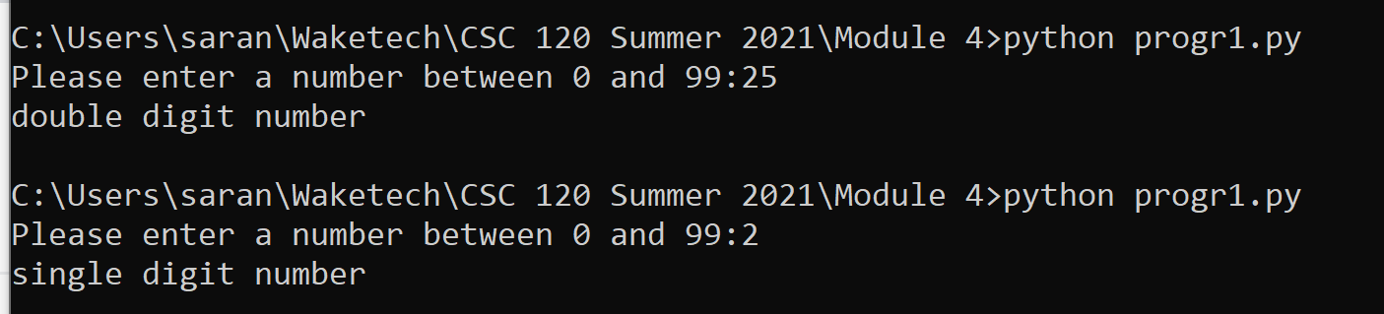

number = int(input("Please enter a number between 0 and 99:"))

if number > 9:

  print("double digit number")

else:

  print("single digit number")

##### Question 3 (10 points)

Write a for loop that prints all even numbers from 10 to 99. (10 included)

for i in range (10, 100, 2):

  print (i)

##### Question 4 (10 points)

### Write a for loop that prints the table of 5 as follows

**Output:**

5

10

15

20

25

30

35

40

45

50

for i in range (5, 51, 5):

  print (i)

##### 

##### Question 5 (10 points)

Write a for loop that prints all the numbers in the table of 5 that are divisible by 3. For example your loop should print the following. Hint: Use an if condition

**Output:**

5

10

15 is divisible by 3

20

25

30 is divisible by 3

35

40

45 is divisible by 3

50

for i in range (5, 51, 5):

  if i % 3 == 0:

    print(i," is divisible by 3")

  else:

    print(i)

##### Question 6A (5 points)

How would you fix the following error?

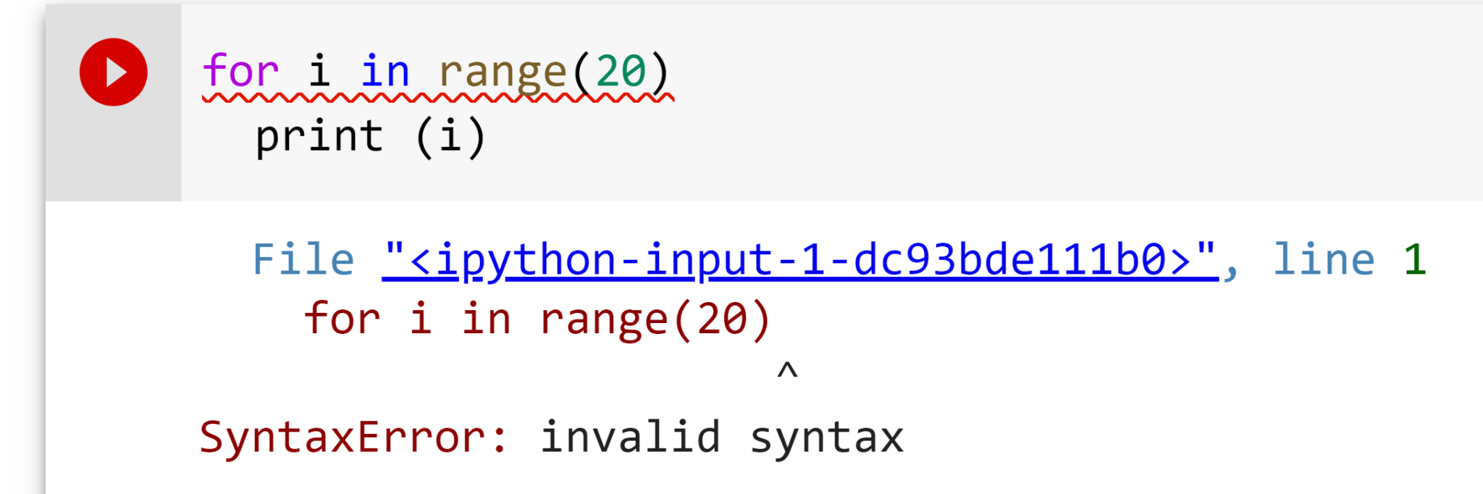

Add a “:” after (20)

for i in range(20):

  print(i)

**Question 6B (10 points)**

How would you fix the following error?

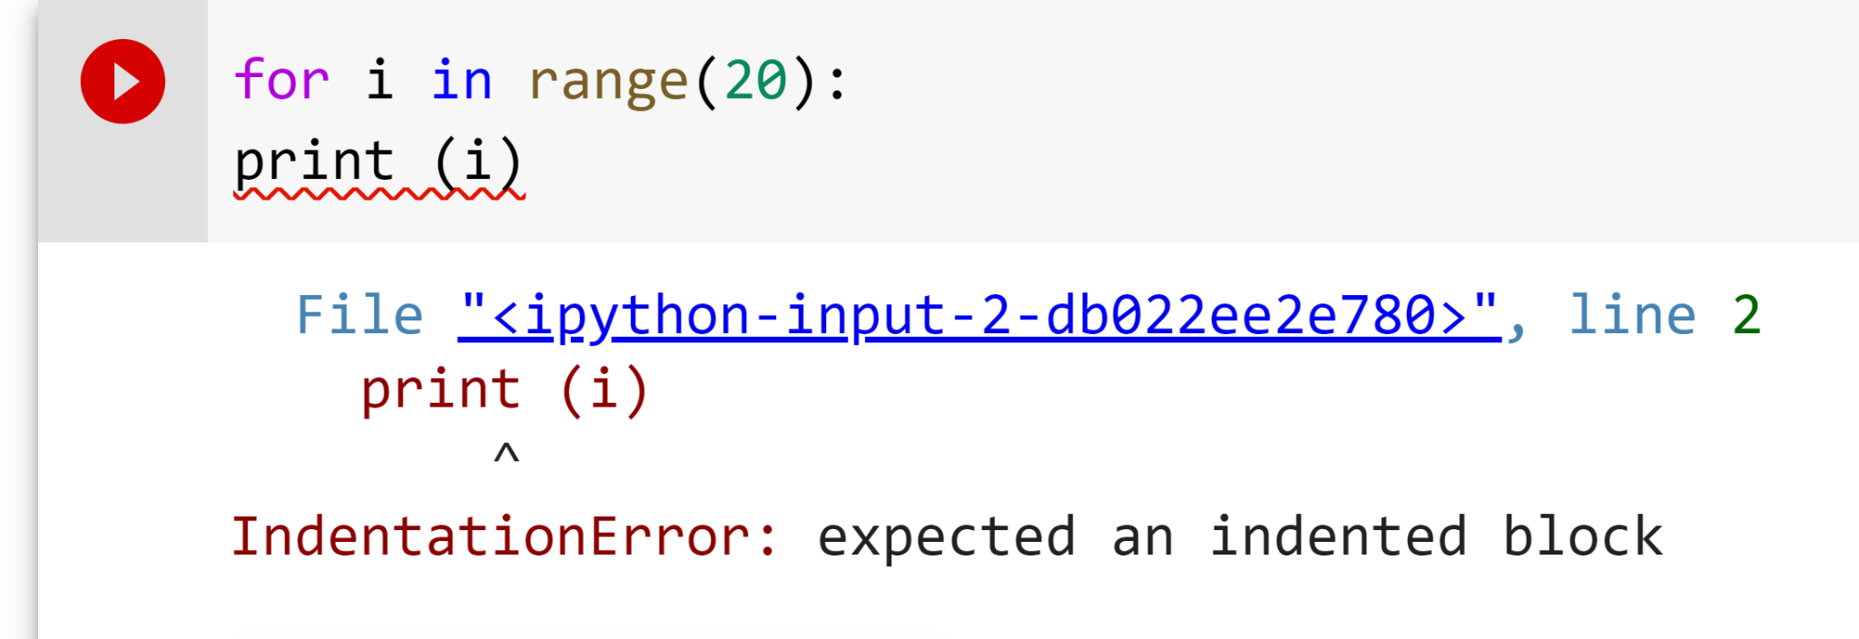

Add an indentation before print.

for i in range (20):

  print(i)

**Question 7 (10 points)**

You have the below list. Print all the elements from this list

# Python code

prices = [10, 130, 25, 64, 91, 66, 42, 18, 141, 64]

prices = [10, 130, 25, 64, 91, 66, 42, 18, 141, 64]

for p in prices:

  print(p)

**Question 8 (10 points)**

You have the below list. Filter all the elements from this list that are adobe 20 and less than 80. Add them to a new list. The name of the list with filtered elements should be **filtered_list.**

# Python code

prices = [10,130,25, 64,91,66,42,18,141,64]

prices = [10,130,25, 64,91,66,42,18,141,64]

filtered_list = []

for p in prices:

  if p > 20 and p < 80:

    filtered_list.append(p)

**Question 9 (10 points)**

Write a program that accepts a username and a password from the user. If the username entered is “student007” and password entered is “new_password”, your program should print a message **“Login successful”.** Otherwise it should print a message **“Try again. Login failure”.**

**Note:** Use the **logical and** in your if condition for full credit

**Expected Output**

**Case 1**

Please enter username: student007

Please enter the password: new_password

Login successful!

**Case 2**

Please enter username: student007

Please enter the password: new111

“Try again. Login failure”.

**Case 3**

Please enter username: student008

Please enter the password: new111

“Try again. Login failure”.

**Case 4**

Please enter username: abcde

Please enter the password: xyzw

“Try again. Login failure”.

uName = input("Please enter username: ")

pWord = input("Please enter the password: ")

if uName == "student007" and pWord == "new_password":

  print("Login successful!")

else:

  print("Try again. Login failure.")

**Question 10 (10 points)**

Write a program to accept a username from the user. If the length of the username is less than 5 or if the length of the username is greater than 16, your program should print “Invalid username”. Otherwise your program should print the message “valid username”.

Use **logical or operator in your if condition** for full credit

Use the len () function example in reference code to find the length of the username which you provide as input to your program

**Expected Output**

**Case 1**

Please enter username: student1

Valid username

**Case 2**

Please enter username: stud

Inalid username

**Case 3**

Please enter username: student12233

Invalid username

uName = input("Please enter username: ")

if len(uName) < 5 or len(uName) > 16:

  print("Invalid username")

else:

  print("Valid username")

**(20 points) Challenge Question 1 (Extra Credit)**

# Python code

item_prices = [10, 40, 1, 16, 25, 34, 49, 40]

You have a list of prices of items in a store. Write a program that prints all pairs of items that add up to 50. Your program should print the output as follows

**Output**

10 , 40

10, 40

1, 49

16, 34

item_prices = [10, 40, 1, 16, 25, 34, 49, 40]

for i in item_prices:

  for n in range(0, len(item_prices)):

    if i + item_prices[n] == 50:

      print(i, item_prices[n])

**(10 points) Challenge Question 2 (Extra Credit)**

#Python code

names = ["sarang","john","lily","jasmine","mara","dave","chester"]

Write a program to search a name in a list of names. If the name is found, print the message “name found: <name>”. Otherwise print name not found. Use the above list of names in your code.

names = ["sarang","john","lily","jasmine","mara","dave","chester"]

nameSearch = input("Please enter a name to search the list: ")

if nameSearch in names:

  print("name found:",nameSearch)

else:

  print("name not found")